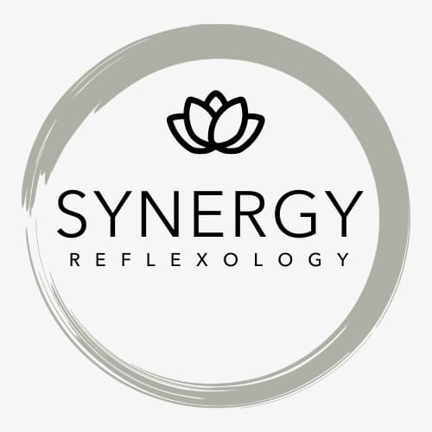

Terms and Conditions for Synergy Reflexology
I am a full member of the Association of Reflexologists (AoR). Being a full member of the AoR demonstrates that I have completed a quality, nationally recognised Diploma in Reflexology and have support from the AoR.

As an AoR member:
- I am bound by the AoR Code of Practice and Ethics.
- I follow the AoR Good Practice Policy and hygiene guidance to ensure client safety.
- I will always be adequately insured for medical malpractice /professional indemnity requirements. The industry standard is in excess of £5 million cover.
- I comply with the AoR Continuing Professional Development requirements which ensures the practice is kept up to date.
- I am compliant with GDPR data protection, please see the separate Privacy policy. Your information will remain confidential at all times.
- As a professional and highly qualified reflexologist with AOR status, I will provide you with the appropriate bespoke treatment and support.

1. Appointments

- When making an appointment you agree to the Terms and Conditions.
- When making the appointment you agree to a consultation with me prior to the treatment and you will disclose any relevant medical or lifestyle information.
- I have health requests of clients as follows:
  - If you have any of the following contraindications you must inform me and understand that I may be unable to give you reflexology treatment; active DVT or pulmonary embolism, fever or any contagious condition, cellulitis
  - You must also inform me if you have any of the following to ensure I can treat you safely; new, acute or undiagnosed pain, allergies, diabetes, epilepsy, osteoporosis, unstable heart conditions or blood pressure, varicose veins, injury or conditions in the area to be treated.
  - If you are a woman I will ask you to disclose the date of your last period and if you may be pregnant. I do not provide reflexology during the first 12 weeks of pregnancy.
- All health information is shared on a strictly confidential basis and ensures that I can provide safe and effective treatment.
- If you have a cough, a fever or loss of taste and smell or have been in touch with anyone with these symptoms please contact me as we may need to postpone your appointment.
- If you present with any condition or symptom which could be a contraindication, I reserve the right to postpone our treatment until medical advice is sought.
- In return I will apply these high standards to myself. Should I feel unwell, unable to treat or it is inadvisable for me to treat, I will explain the situation to you as soon as possible before your treatment.

2. Fees
- The fees are available on my website Price List
- Fees are payable at the time of treatment by card payment, cash, bank transfer or valid gift voucher.
- I reserve the right to choose to use discretion regarding the application of any discounts.
3. Cancellation Policy
- I have a 24 hour cancellation policy. As you are aware the business is dependent on the number of clients I can see in the clinic hours. Therefore, if you are unable to make a previously arranged appointment, I request that you provide me with at least 24 hours’ notice. This will allow me the option to re-book the time slot with someone on the waiting list.
- Less than 24 hours’ notice may result in a fair-use fee of 50 % of the usual treatment cost. This fee will be required to be settled prior to any future bookings.
5. Treatment packages
- When offer the option to book a package of treatments, these are provided at a reduced price as they are paid for in advance.
- These treatments can be booked during normal working hours with no restrictions.
- Where an appointment is booked and missed, the cancellation policy will apply.
- These treatments are non-refundable.
- These treatments are not required to be used within a specific time frame.
- These treatments have to be used within one year.
6. Vouchers
- I supply the option to buy vouchers for treatments. These may be given as gifts.
- These treatments can be booked during normal working hours with no restrictions.
- These vouchers are required to be used within 6 months.
7. Use of background music
- I only play Royalty free music within the business and therefore I am not required to have The Music License. Unless you are in your own home, I am unable to play your preferred music selection due to UK laws.

8. Provision of additional therapies
- I sometimes offer other therapies in addition to reflexology. I provide these therapies to the same high standard expected by the AoR for reflexology. I also have insurance in place for these additional therapies.
- These therapies include, Indian Head Massage / scalp massage and crystal therapy.

